Contents

Overview: 2

Architecture: 2

Instruction: 2

# 

# **Overview:**

In this runbook we will see that how we can disable the internet connection in the azure virtual machine.

# **Architecture:**

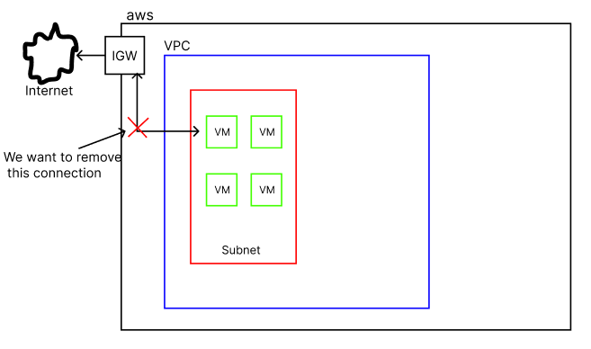

# **Instruction:**

The steps to disable the internet connection in the azure virtual machine is as follows.

1. Log in to your azure portal and create a network security group and set the following outbound rules for it.  
   *Source: Any  
   Source Port Ranges: *  
   Destination: Any  
   Service: Custom  
   Destination port ranges: 8080  
   Protocol: Any  
   Action: Deny  
   Name: Denyinternet*  
   Click on **Add** and you will have followed outbound security rule.  
   
2. If you have an already network security group associated with your azure machine, then skip step 1 and make changes in the existing security group and add outbound rule to it and then you are good to go. If not follow the next steps
3. Assign your VM to newly created security group  
   go to your VM -> Change the NSG to new one.
4. Now for the test connectivity if your VM is windows then   
   Restart the VM > Go to RDP > Open Internet Explorer > Try [www.bing.com](http://www.bing.com)  
   If you are on Linux then   
   Restart the VM > Go to CMD > run command ping -c 3 google.com